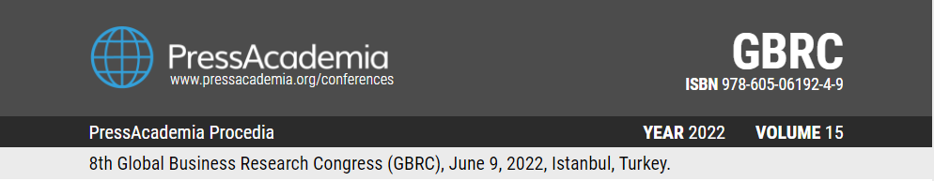

TITLE OF PAPER (11 punto, calibri, bold, all uppercase letters)

DOI: 10.17261/Pressacademia.2022….
PAP- V.15-2022(..)-p….

Author¹, Author², Author³
¹Name of University, Name of Department, Name of City, Name of Country.
email: , ORCID: 0000-0000-0000-0000
²Name of University, Name of Department, Name of City, Name of Country.
email: , ORCID: 0000-0000-0000-0000
³Name of University, Name of Department, Name of City, Name of Country.
email: , ORCID: 0000-0000-0000-0000

To cite this document
Author 1, Author 2, Author 3, (2022). Title of paper……………………………………………………………………………………………………………………….. PressAcademia Procedia (PAP), V.15, p.
Permanent link to this document: http://doi.org/10.17261/Pressacademia.2022.........
Copyright: Published by PressAcademia and limited licensed re-use rights only.

ABSTRACT
Purpose- The purpose of this study is to ……

Methodology- The study employs …

Findings- The analysis reveals that…..

Conclusion- based upon the analyisis7Findings it may be concluded that…

Keywords: 5 keywords
JEL Codes: 3 JEL codes

1. INTRODUCTION (10 punto calibri)
(8 punto calibri, single space) ………Information technologies, which affect a wide range of aspects of life, ranging from space research to online shopping, economics to scientific software, are also widely employed in the education sector.

2. LITERATURE REVIEW (10 punto calibri)
(9 punto calibri, single space) ………In the literature, there are many studies about creation of students absence and attendance system that some of which includes mobile-based attendance system

3. DATA AND METHODOLOGY (10 punto calibri)
(9 punto calibri, single space) ………The study adopted a quantitative research method, and the survey is used

Table 1: Demographics
Variables Categories N (%) Variables Catergories N (%)
Gender | Male |  |  | Usage of IT Apps (Hours) | 1-2 per Week
 | Female |  |  |  | 3-4 per Week
Age | 20-30 |  |  |  | 1-2 per Day
 | 31-40 |  |  |  | 3-4 per Day
 | 41-50 |  |  |  | 4+ per Day
 | 51-60 |  |  | IT Usage Level | Very Few
 | 60+ |  |  |  | Enough
Title | Instructor |  |  |  | Good
 | Research Assistant |  |  |  | Very Good
 | Assistant Professor |  |  | Using OAS Since When | Less Than 1 Month
 | Associate Professor |  |  |  | Between 1-3 Months
 | Professor |  |  |  | Between 4-6 Months
Graduation | Bachelor |  |  |  | Between 7-12 Months
 | Master |  |  |  | Longer Than 1 Year
 | Doctor of Philosophy |  |  | Usage of OAS Level | Very Few
Experience | 0-3 Years |  |  |  | Once a Week
 | 4-6 Years |  |  |  | Several a Week
 | 7-9 Years |  |  |  | Once a Day
 | 10-12 Years |  |  |  | Several a Day
 | 13+ Years
 | Total |  |  |  | Total

4. FINDINGS (10 punto calibri)
(9 punto calibri, single space) ………In this study, descriptive statistics (as above), inter-correlations, independent samples T-test, and One-Way ANOVA tests were used to examine if there were differences in between TRI and TAM variables among defined groups. Below the tables, we explained some interrelationships among variables.

5. CONCLUSION (10 punto calibri)
(9 punto calibri, single space) ………

REFERENCES
(8 punto, calibri, single space) APA style – AT LLEAST 10 REFERENCES

Field, A. (2009). Discovering statistics using SPSS 3rd ed. Thousand Oaks, California: SAGE Pub.
Finney, J. (1970). Time and again. New York, NY: Simon and Schuster.
Hair, J.F., Black, W.C., Babin, B.J., Anderson, R.E. (2010). Multivariate Data Analysis. Seventh Edition. Essex: Prentice Hall.
Jacksi K. (2015). Design and implementation of online submission and peer review system: a case study of e-journal of University of Zakho. International Journal of Scientific & Technology Research, 4(8): 83-85.
Norusis, M. J. (1993). SPSS for windows: professional statics. Release 6.0, Chicago: SPSS Inc.
Nunnally, J. C. (1978). Psychometric Theory (2nd ed.), New York: McGraw-Hill.

